Sticky-Evidence-Illustration.R
ian
2019-07-29
rm(list=ls(all=TRUE))
#clear console
cat("\014")

scale_param<- 1.5 #for weighting function
weight_fun<- function(distance,scale_param){
the_weight<- 1-exp(-distance/scale_param)
return(the_weight)
}
#sample raw uncorrelated (across time) evidence
raw_evidence<-rnorm(10^3,mean=0,sd=1)
sticky_evidence<-raw_evidence
weights<-numeric(length(sticky_evidence))
distances<-numeric(length(sticky_evidence))
for(trial in 2:length(sticky_evidence)){ #starts at second trial because there can be no prior evidence for trial 1
distance<-abs(sticky_evidence[trial]-sticky_evidence[trial-1])
w <-weight_fun(distance,scale_param)
#the sticky weighting process
sticky_evidence[trial]<-(w)*sticky_evidence[trial]+(1-w)*sticky_evidence[trial-1]
weights[trial]<-w
distances[trial]<-distance
} #end of trial loop
output<-data.frame(re=raw_evidence,
se=sticky_evidence,
w=weights,
d=distances)
print(head(output))
## re se w d
## 1 -1.3519396 -1.3519396 0.00000000 0.00000000
## 2 0.8725943 0.3677348 0.77304933 2.22453392
## 3 0.3967134 0.3682893 0.01913361 0.02897854
## 4 0.2574025 0.3603877 0.07125818 0.11088674
## 5 -0.7299261 -0.2028500 0.51658311 1.09031382
## 6 0.1626076 -0.1238275 0.21622901 0.36545760
#plot relation of weights and evidence distances
with(output,
plot(w,d))
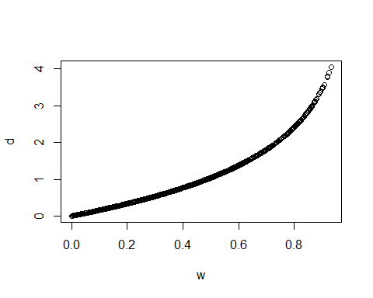
#autocorrelation plot of raw evidence
print(acf(output$re,lag.max=5))
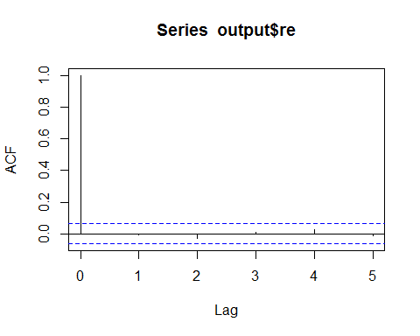
##
## Autocorrelations of series 'output$re', by lag
##
## 0 1 2 3 4 5
## 1.000 -0.006 -0.031 0.011 0.026 -0.010
#autocorrelation plot of sticky evidence
print(acf(output$se,lag.max=5))
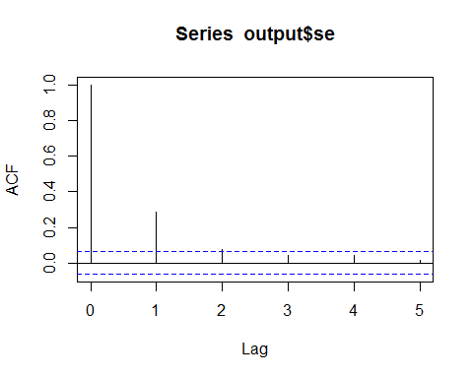
##
## Autocorrelations of series 'output$se', by lag
##
## 0 1 2 3 4 5
## 1.000 0.285 0.075 0.040 0.043 0.016
samp=50
plot(1:samp,output$re[1:samp],type='l')
lines(1:samp,output$se[1:samp],type='l',col='red')
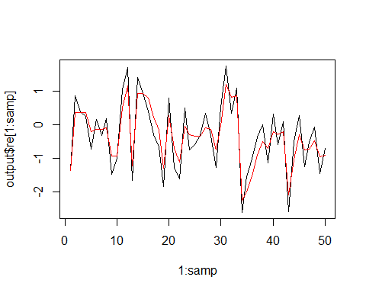
print(apply(output,2,FUN='sd'))
## re se w d
## 1.0367588 0.7960157 0.2402895 0.7939131

